Practical no 1
Comprehensive NLP Pipeline for Linguistic Analysis Using spaCy and NLTK

Introduction to NLP:

1. What is NLP?
Natural Language Processing (NLP) is a field of Artificial Intelligence (AI) and Linguistics that focuses on enabling computers to understand, interpret, and generate human language.
It’s the technology behind things like:
- Chatbots (e.g., ChatGPT, Gemini)
- Voice assistants (Siri, Alexa)
- Machine translation (Google Translate)
- Sentiment analysis (detecting emotions in text)

2. Why is NLP important?
Human language is:
- Complex (grammar, meaning, context)
- Ambiguous (same word can have multiple meanings)
- Variable (different styles, dialects, slang)
NLP allows machines to:
- Extract meaning from text or speech
- Communicate with humans in a natural way
- Process large volumes of language data efficiently

3. Main Tasks in NLP
Some core tasks include:
- Tokenization: Splitting text into words or sentences
- Part-of-Speech Tagging: Identifying nouns, verbs, etc.
- Named Entity Recognition (NER): Detecting names, places, dates
- Sentiment Analysis: Identifying opinions/emotions
- Machine Translation: Converting text from one language to another
- Text Summarization: Creating concise summaries
- Speech Recognition: Converting spoken language to text

4. How NLP Works
NLP combines:
- Linguistics – Grammar, syntax, semantics
- Machine Learning (ML) – Learning patterns from data
- Deep Learning (DL) – Using neural networks to capture context and meaning
Common libraries & frameworks:
- NLTK, spaCy – For basic NLP processing
- Transformers (Hugging Face) – For advanced deep learning models like BERT and GPT
- SpeechRecognition – For speech-to-text tasks

5. Applications of NLP
- Search engines (Google search suggestions)
- Customer support (chatbots, email classification)
- Healthcare (analyzing medical records)
- Social media monitoring (detecting trends and opinions)

NLP Pipeline Flowchart:
1. Sentence Segmentation
Sentence segmentation is the process of breaking a large text or paragraph into individual sentences. This is an essential step because most NLP tasks are performed on a sentence-by-sentence basis.
Example:
Input: "I love programming. It makes me happy."
Output: ["I love programming.", "It makes me happy."]

2. Word Tokenization
Word tokenization splits each sentence into smaller units called tokens, which may be words, punctuation marks, or subwords.
Example:
Sentence: "I love programming."
Tokens: ["I", "love", "programming", "."]

3. Stemming
Stemming reduces words to their base or root form by removing suffixes and prefixes, often without considering grammar rules. It may produce non-dictionary words.
Example:
"playing" → "play"
"studies" → "studi"

4. Lemmatization
Lemmatization also reduces words to their base form but uses vocabulary and grammar rules, ensuring the result is a valid dictionary word.
Example:
"playing" → "play"
"better" → "good"

5. Identifying Stop Words
Stop words are commonly used words (such as "is", "and", "the") that usually carry less important meaning in text analysis. This step involves detecting and optionally removing them to reduce noise.
Example:
Sentence: "I am learning NLP"
After removing stop words: ["learning", "NLP"]

6. Dependency Parsing
Dependency parsing analyzes the grammatical structure of a sentence by identifying the relationships between words.
Example:
Sentence: "I love programming."
- "love" → main verb
- "I" → subject of "love"
- "programming" → object of "love"

7. Part-of-Speech (POS) Tagging
This step assigns each token a grammatical role, such as noun, verb, adjective, etc. POS tagging is essential for syntactic analysis.
Example:
Sentence: "The cat sleeps."
Tags: [("The", DET), ("cat", NOUN), ("sleeps", VERB)]

8. Named Entity Recognition (NER)
NER identifies and classifies named entities such as people, organizations, locations, dates, and more.
Example:
Sentence: "Apple Inc. is based in California."
NER Output:
- Apple Inc. → Organization
- California → Location

9. Chunking
Chunking groups tokens or words into meaningful phrases (such as noun phrases or verb phrases) based on POS tags and grammar patterns.
Example:
Sentence: "The big brown dog"
Noun Phrase (NP) Chunk: ["The big brown dog"]
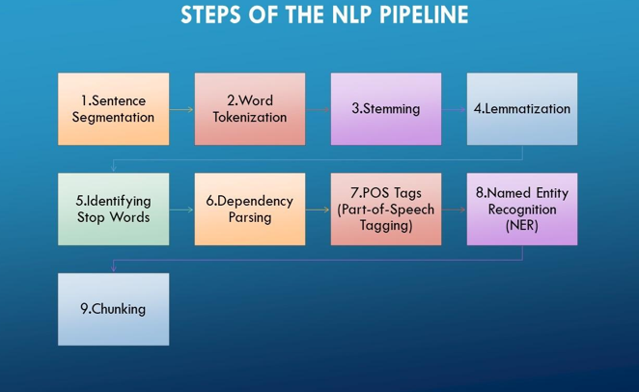

Code:
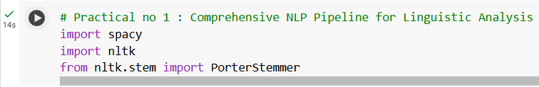
  - Importing Libraries:

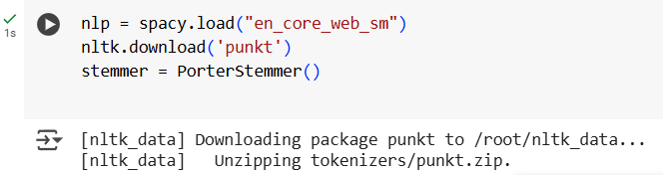
  - Loading Models and Resources:

  - Defining the Input Text:

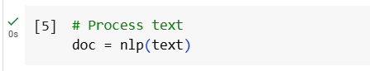
  - Processing Text with spaCy:

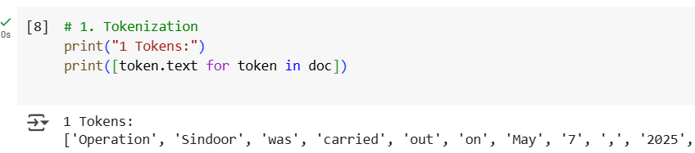
  - Tokenization:

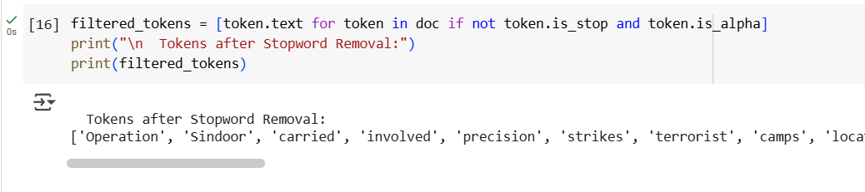
  - Stopword Removal:

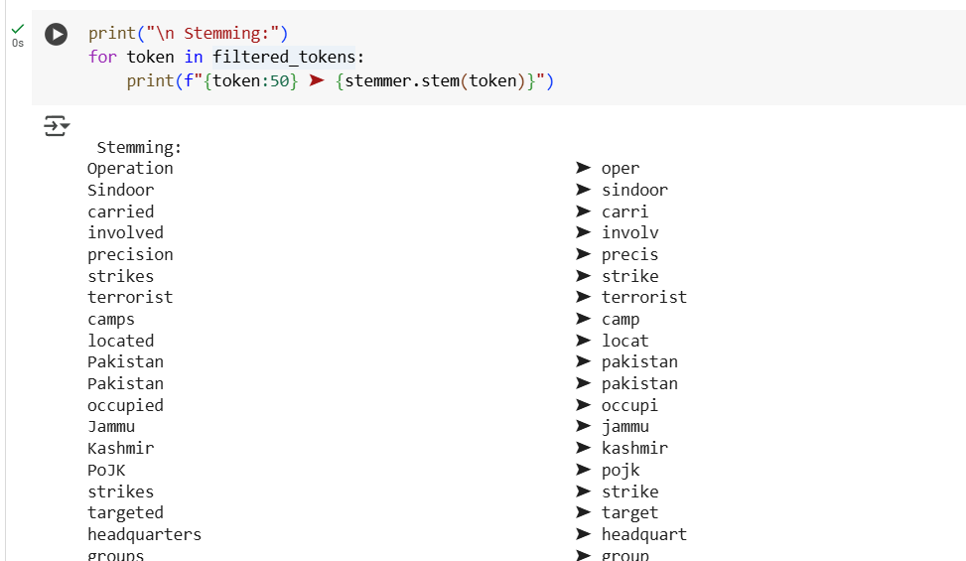
  - Stemming:

  - Lemmatization:
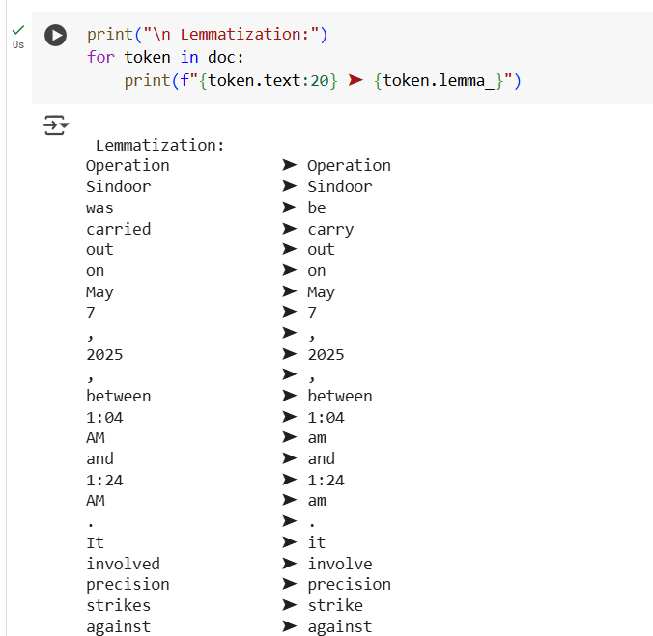

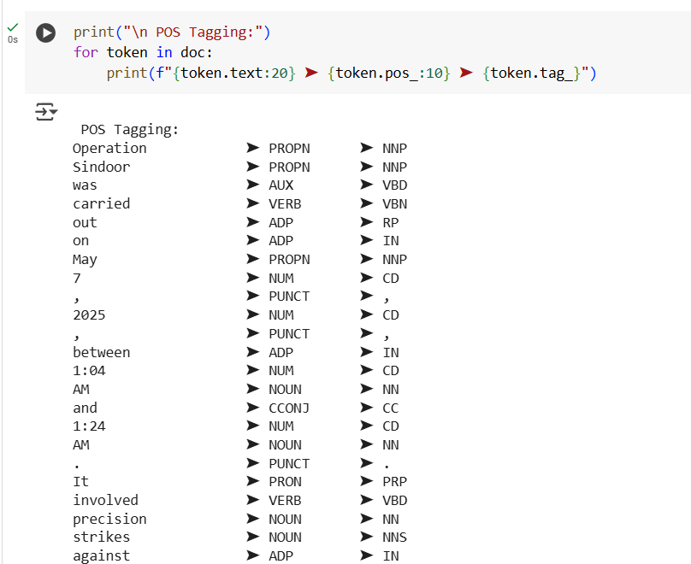
  - POS Tagging:

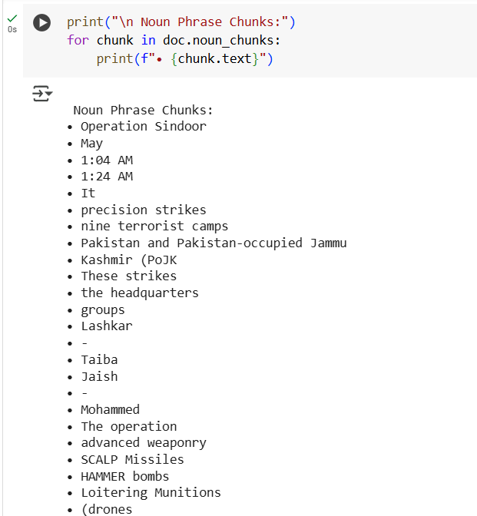
  - Noun Phrase Chunking:
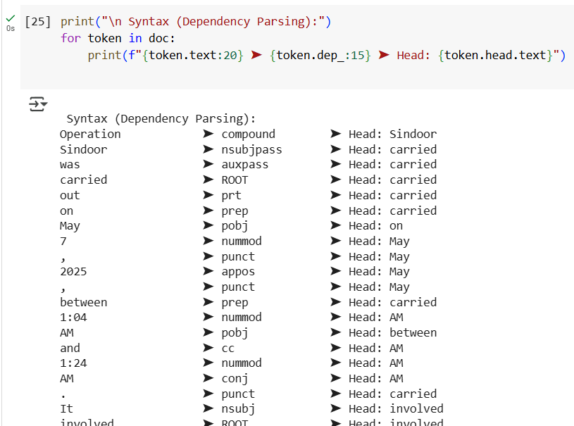
  - Dependency Parsing:

  - Semantics: Named Entity Recognition
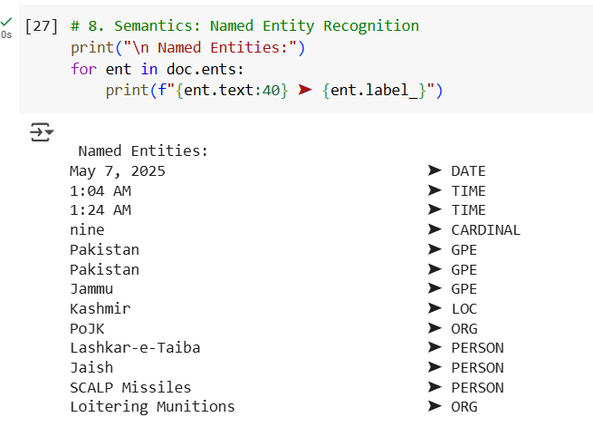

Practical no 2
Probability estimation in NLP using N-gram models

Introduction to N-gram
An n-gram is simply a sequence of n items from a given text or speech.
These items can be characters, syllables, or most commonly, words. N-grams are widely used in Natural Language Processing (NLP) to analyze text patterns, predict words, and model language.

Definition
- If n = 1 → Unigram → single word (e.g., "The", "dog")
- If n = 2 → Bigram → two consecutive words (e.g., "The dog", "dog barks")
- If n = 3 → Trigram → three consecutive words (e.g., "The dog barks")
- General case → n-gram → sequence of n consecutive items.

Example
Sentence: "I love programming"
- Unigrams: ["I", "love", "programming"]
- Bigrams: [("I", "love"), ("love", "programming")]
- Trigrams: [("I", "love", "programming")]

Applications of N-grams
- Text Prediction
  - Predict the next word based on the previous (n–1) words.
Example: “I am going to” → likely next word: “school”.
- Spelling and Grammar Correction
  - Detect unlikely word combinations.
- Search Engines
  - Match phrases and improve query suggestions.
- Machine Translation
  - Preserve context by looking at word sequences.
- Sentiment Analysis
  - Capture patterns that single words miss.

Advantages
- Easy to implement and understand.
- Captures some context in text.
Limitations
- Larger n means more memory and data requirements.
- Doesn’t capture long-distance relationships between words.
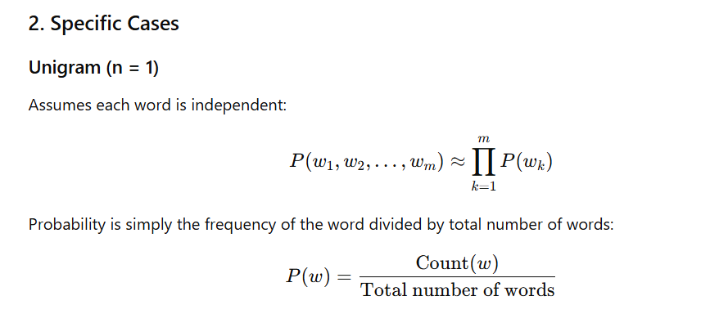
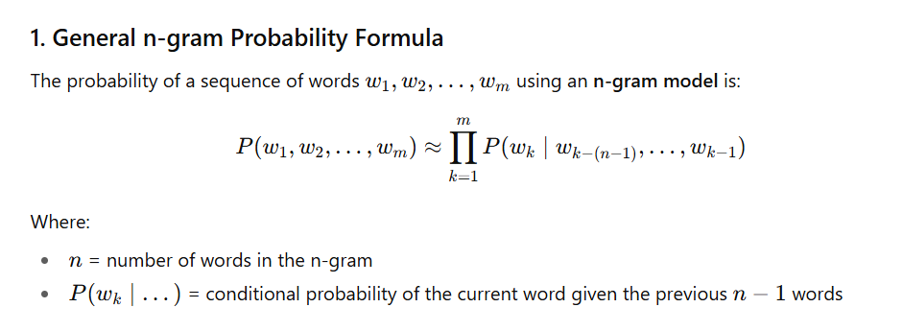
- Suffers from data sparsity when n is large.
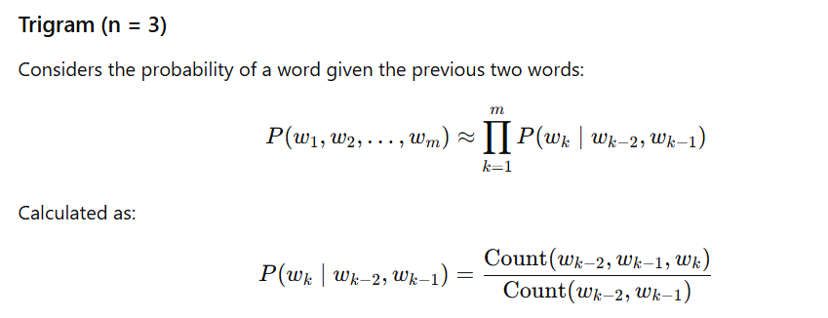
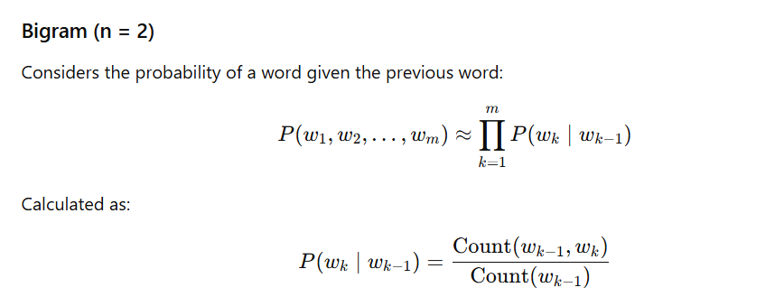

Code:
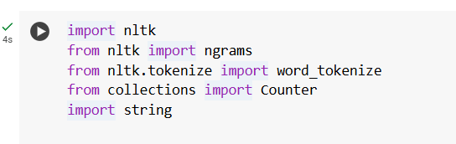
- Importing Libraries:

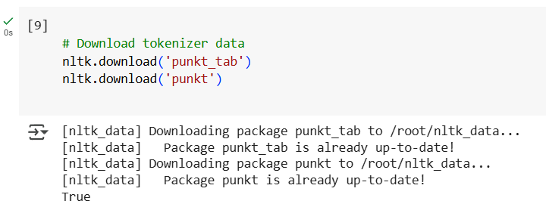
- Download tokenizer data:

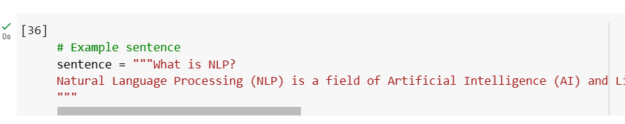
- Example Sentence:

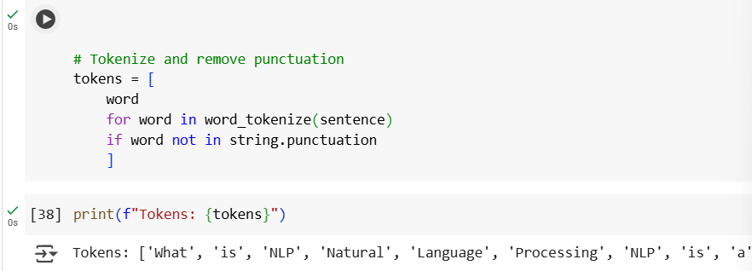
- Tokenize and remove punctuation:
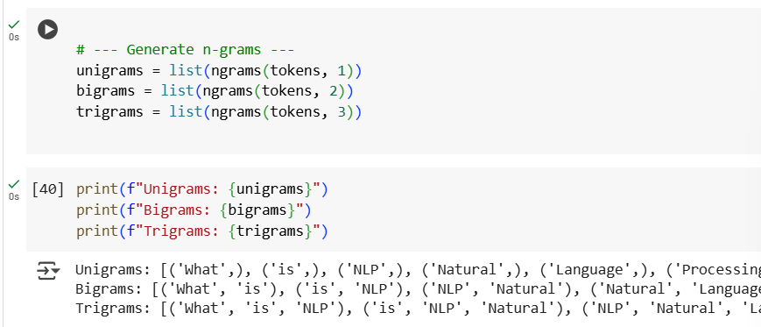
- Generate n-grams:
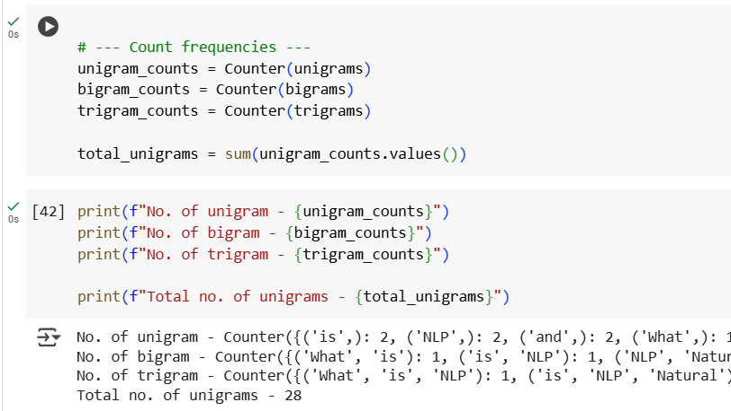
- Count Frequencies:

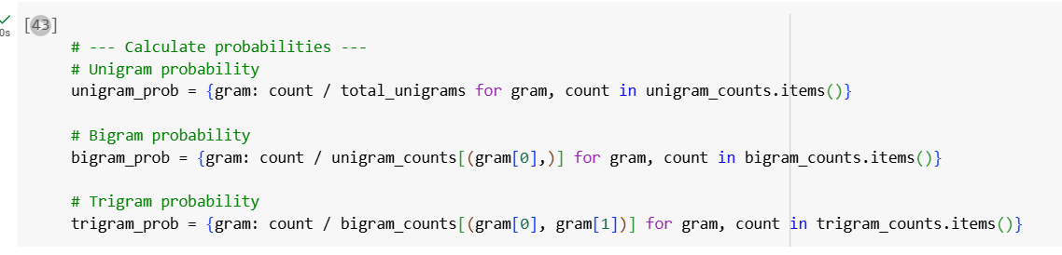
- Calculate probabilities:

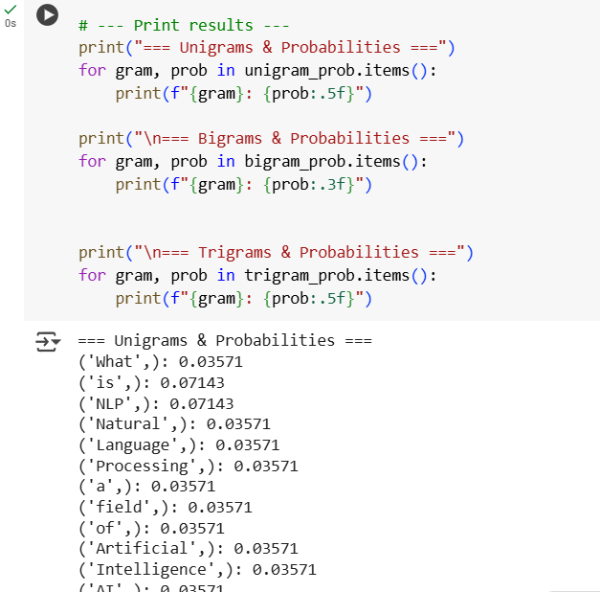
- Output:

